**Learning web hub application**

**Project Plan**

TABLE OF CONTENTS

**INTRODUCTION** 2

Purpose of Plan 2

**GOALS AND OBJECTIVES** 2

Project Goals and Objectives 2

**SCOPE** 2

Scope 2

Risk Assessment 3

Milestones 3

**ASSUMPTIONS 3**

Project Assumptions 3

**CONSTRAINTS 3**

Project Constraints 3

**PROJECT MANAGEMENT APPROACH 3**

Project Timeline 3

Project Roles and Responsibilities 4

Issue Management 4

**APPROVALS 4**

Sign-off Sheet 4

**INTRODUCTION**

**Purpose of Plan**

Learning hub is web application that acts as an online free hosting tons, so users can explore and receive knowledge in different categories, users also can share their knowledge, they can publish article, upload video and record voice

**GOALS AND OBJECTIVES**

**Project Goals and Objectives**

The main goal of the project, is to allow users to share their knowledge easily and enable them to publish articles, upload videos and record voices, also ,to enable them explore and receive knowledge in different categories and allow them to rate other articles ,they will get notifications from the website and rate other users’ articles

**SCOPE**

**Scope Definition**

* User will be able to Login and Register in websites
* Making an online web application based on Chrome & Firefox browser on windows operating system
* The application supports English language only
* The application has only one admin who accepts or rejects the article
* The audio format must be mp3 format to be uploaded and the videos format must be mp4 only
* Users can rate other users’ articles , user can publish article, upload video and record voice

**Risk Assessment**

Click-on the link

**Milestones**

|  |  |  |
| --- | --- | --- |
| **Milestone** | **Description** | **Delivery Date** |
| First Milestone | 1-project plan Document  2- SRs Document  3-SIQ Sheet  4-CM tool  5- Project Schedule  6-Risk sheet  7-Issues sheet  8-RTM  9-SRS PR sheet | 4/5/2019 |
| Second Milestone |  |  |
| Third Milestone |  |  |
|  |  |  |

**WBS**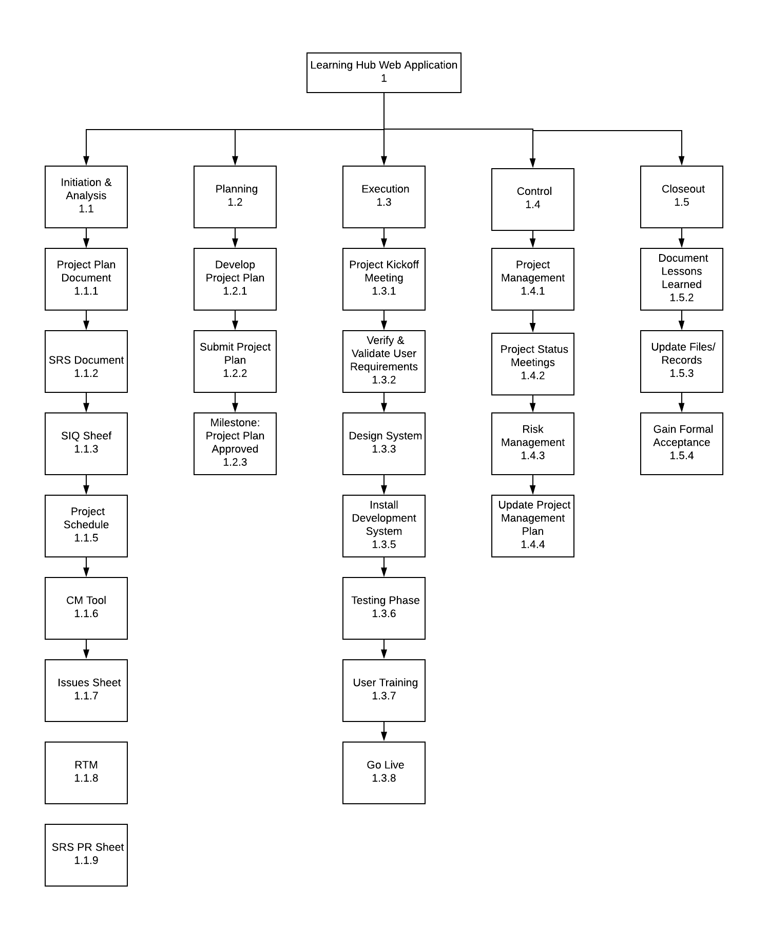

**ASSUMPTIONS**

**Project Assumptions**

* The project does not have descope .
* The resources identified will be available upon request
* The system can accept 10 users
* The system have 4 categories that are displayed for the user

**CONSTRAINTS**

**Project Constraints**

* The project must work on chrome or FireFox only
* Staff must complete the project within normal working hours
* There’s limited time for each iteration
* Unique user ID

**PROJECT MANAGEMENT APPROACH**

**Project Timeline**

Click-on the link

**Project Roles and Responsibilities**

Click-on the link

**Issue Management**

Click-on the link

**APPROVALS**

**Sign-off Sheet**

***I have read the above Project Plan and will abide by its terms and conditions and pledge my full commitment and support for the Project Plan.***

**Project Manager:**

Date

**Steering Committee:**

Date